Sonoda Women’s University

園田学園女子大学

Incoming Exchange Student Guidebook

Information on Studying, Living and Traveling in Japan

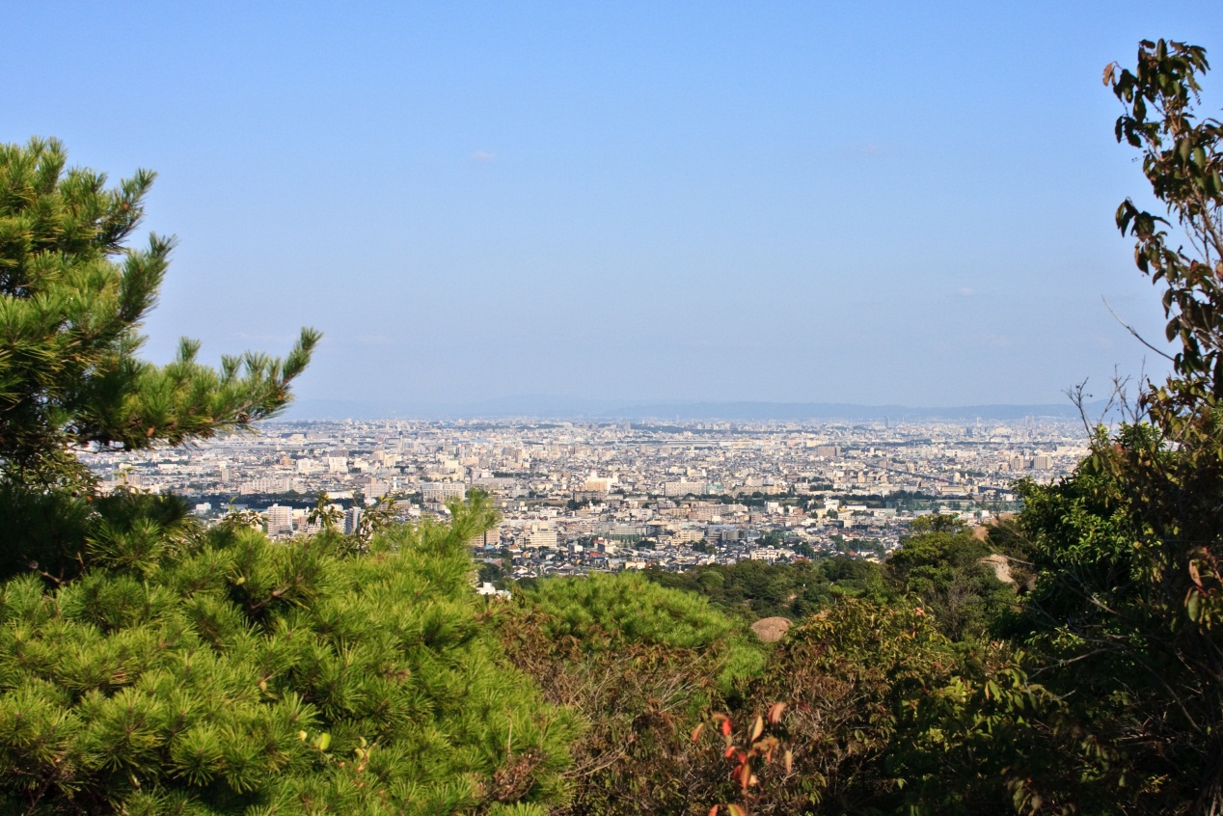

Sonoda Women’s University International Exchange Center

園田学園女子大学国際交流センター

Basic Costs in Japan

Below are a few costs for common items in Japan. You can use this to help budget for your trip.
Meals | Transportation
university cafeteria lunch: \500  restaurant lunch: \700-\1500  restaurant dinner: \1000-\2000  takeaway meal: \700-\1000  supermarket readymade meal: \400-\1000 | Hotel to downtown Kobe (Sannomiya) via  Hanshin Railway: \260  Hotel to downtown Osaka (Umeda) via  Hanshin Railway: \240  Osaka to Tokyo Shinkansen: \16000  Osaka to Hiroshima Shinkansen: \11000  Osaka & Hiroshima 5 day rail pass: \15000
Eating Out | Markets and Convenience Stores
basic bowl of ramen: \600  special bowl of ramen: \1000  all you can eat yakiniku: \3000  delivery 1 topping large pizza: \2500  basic pork okonomiyaki: \700  tuna nigiri sushi (mid-range, 2p): \350  Starbucks grande latte: \410  McDonalds Big Mac set: \670  soft drink: \400  standard beer: \600  Student night out with drinks: \3000-\6000 | basic tuna rice ball: \120  small bag of candy: \120  1 convenience store banana: \100  bag of mikan oranges: \300  bag of potato chips: \200  ham and egg sandwich: \250  lunch noodle salad: \400  a mixed nigiri sushi set: \500  500ml drink - vending machine: \160  500ml drink - supermarket: \130  standard beer: \220
Daily Goods | Gifts & Souvenirs
Box of tissues: \200  Toothpaste: \250  shampoo: \500  Over the counter cold medicine: \2000 | Typical food based gifts: \600~\1500  pocket hand towel: \500  keychain or souvenir pen: \500  t-shirt: \3500
Entertainment | Others
hot spring bathhouse entrance: \800  Ferris wheel ride: \800-\1500  movie tickets: \1700  aquarium entrance: \2000  Universal Studios Japan entrance: \7400 | iPad Pro 9.7in: \66800  3GB Data SIM: \4000  basic unlocked android phone: \10000  capsule hotel: \4500/night  dorm room in a hostel: \3500/night
※All prices listed in Japan in stores must have the pre-tax (税別) and post-tax (税込) costs displayed. Short term visitors can shop tax free if the total cost of goods is over \5000 at participating stores

SIM CARDS
NOTE: All prepaid tourist SIM cards in Japan are DATA ONLY… no phone or SMS ability.
NOTE: Some cards require you to register with your passport after doing the APN settings.

You have two options for SIM cards order online for delivery to hotel or airport or purchase upon arrival at the airport or electronics store. Prepurchasing your card online seems to be the best option if you are not afriad about picking it up and delivery. If you want to purchase a card upon arrival, the electroics stores near the major train stations and tourist centers are typically cheaper. Yodobashi Camera or Bic Camera are the best options.
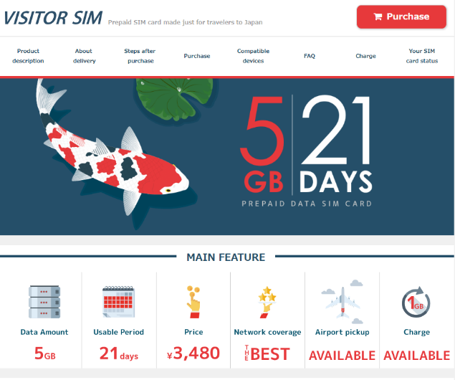
Bmobile is probably the best deal available at the moment but you need to order it online
bmobile: http://www.bmobile.ne.jp/english/
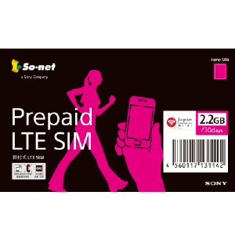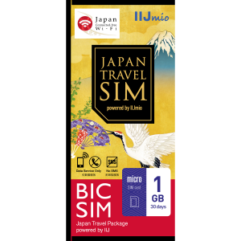
Sonet and IIJmio also sell SIM Cards at stores and vending machines. They have been popular among exchange students in the past.

This is an example of what is for sale at Narita (NRT), Haneda (HND) or Kansai (KIX):
https://www.jalabc.com/en/data-sim-mobile/sim-cards.html

Prices change often so doing your own research is recommended. New Zealand students have also mentioned that international roaming options are also affordable so please check with your home carrier before coming to Japan.
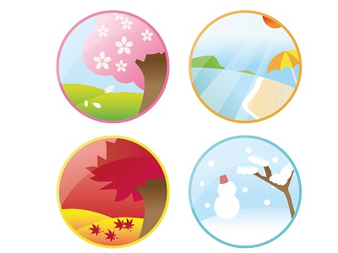
We hope you are getting excited for your trip to Sonoda Gakuen and Japan. Whether you will be staying with us for a long time or only a few weeks there are a few things you should bring with you. Please read over this list carefully; it will help you have a pleasant stay.

Clothing.
Sonoda Gakuen is located in the Kansai region of Japan. Here in the city we have four distinct seasons with hot, humid summers and mild winters. For those of you coming to Japan from the Southern Hemisphere please remember the seasons are opposite. Outside of winter, it will be more humid than you are expecting. Clothing is very affordable in Japan so buying any items you need here is also an option. Note: It can be harder to find larger sized clothing or shoes bigger than 27cm.

Weather
 | Spring  (Mar-May) | Summer  (June-Aug) | Fall  (Sep-Nov) | Winter  (Dec-Feb)
Min/Max (℃) | 8/18 | 20/37 | 15/28 | 3/12
Humidity | High | High | High to Fair | Fair / Dry
Rainfall (mm) | 130 | 150 | 120 | 50
June is the rainiest month while December has the least amount of rain. There is some rainfall for an average of 15 days a month. Around Sonoda Women’s University snow does fall in the winter, but it rarely accumulates.

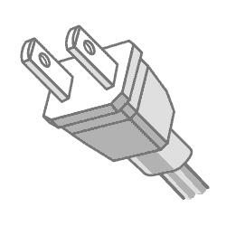
Electronics.
Japan uses a “Type A” plug. The mains electricity is 100V at 50Hz/60Hz. If your electrical appliance or power adapter says “100-240V” or “100V” and “50-60Hz” on it you can use it in Japan with only an adaptor to change the type (shape) of the plug. If it only says “240V” for example you will need a more expensive power converter. USB cables and chargers for popular electronics are very cheap in Japan so buying them here is also an option.
type A plug

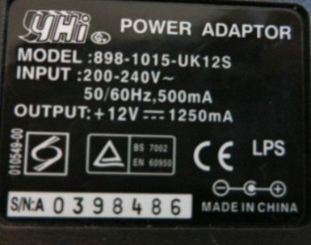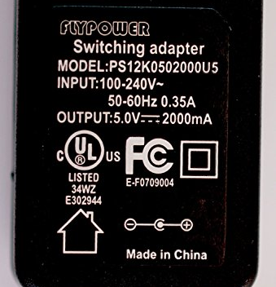
will work
will NOT work
Packing List
Please prepare these things or plan on purchasing them in Japan
Item |  | Spring | Summer | Fall | Winter
 | Heavy winter coat (preferably wind and water resistant) |  |  |  | X
 | Sunhat | X | X | X
 | Light waterproof jacket | X | X | X
 | Sweatshirt, hoodie, or sweater | X |  | X | X
 | Long underwear or thick tights |  |  |  | X
 | Thick socks |  |  |  | X
 | Multiple pairs of socks | X | X | X | X
 | Comfortable walking shoes | X | X | X | X
 | Shoes that you can take off and put on easily | X | X | X | X
 | Bathing suit |  | X
 | Track suit, room wear and/or pajamas | X | X | X | X
 | Scarf |  |  |  | X
 | A less casual outfit for ceremonies or presentations at school | X | X | X | X
 | Shorts | X | X | X
 | Jeans / pants | X | X | X | X
 | Long skirt or dress | X | X | X | X
 | Long sleeve shirts | X |  | X | X
 | Short sleeve shirts | X | X | X
 | Hand towels / small towels | X | X | X | X
 | Daypack / backpack | X | X | X | X
 | Deodorant | X | X | X | X
 | Sunscreen |  | X | X
 | Photocopy of passport and other critical identifying documents | X | X | X | X
 | Printed copies of return e-tickets | X | X | X | X
 | Small souvenirs or gifts | X | X | X | X
 | Goods needed for cultural exchange lessons | X | X | X | X
 | ***Small weekend bag / duffel bag*** | Exchange trips with weekend homestays

Amagasaki
Sonoda Gakuen is located in Amagasaki City. Amagasaki is a mixed residential and industrial city. The city gets more and more industrial as it gets closer to the Osaka Bay but there are residential areas throughout the city. The population as of 2014 is 460,000 people in an area of about 50km². The mayor of Amagasaki is Kazumi Inamura an independent formally of the Green Party. The city’s image is middle class and industrial, especially when compared to Nishinomiya and Ashiya to the west.
The city is bordered on the west by the Mukogawa River and Nishinomiya City. On the east, Amagasaki is bordered by Osaka somewhat defined by the Kanzakigawa River. To the south the city extends into Osaka Bay. All of this land has been reclaimed over hundreds of years. The natural shoreline was generally around the Hanshin Railway Line. To the north there is a haphazard border with Itami City and Toyonaka City. Although part of Hyogo Prefecture, Amagasaki is closer to Osaka. Interesting fact, Amagasaki shares the same telephone area code (06) as Osaka instead of having a separate one as other surrounding cities do.
The city has a few focal points centered on major train stations. Both JR Amagasaki and Hanshin Amagasaki have large shopping malls connected to the stations, hotels, and multistory apartment mansions. Hanshin Amagasaki also connects to the Sanwa shopping street, one of the largest in the nation. Tsukaguchi, where Sonoda Gakuen is, and Tachibana are also focal points in the city.
In the southwest of the city is Amagsaki Center Pool, this is a boat racing facility for the betting game called Kyotei. Horseracing (keiba 競馬) is done at the Sonoda Racecourse in the northeast. Other attractions in the city is the city sports park (Sogoundokouen 総合運動公園) and the Amagasaki Fishing Park (Uotsurikouen 魚つり公園) where the Mukogawa River meets the Osaka Bay. Amagasaki, while being a nice place to live, does not have the attractions of nearby cities Osaka, Kobe or even Nishinomiya which has a major baseball stadium.

Former Amagasaki City Bus Mascot “Amako”

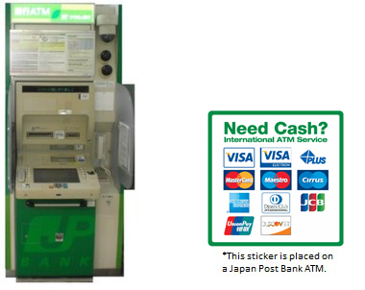
Money and Banking
Japan is a cash based society. It is not uncommon for people to carry around more than USD $1,000 in cash on them. Credit cards are still not universally accepted throughout the country. Do not expect to be able to pay by credit card. Shops in large malls, department stores and some chain restaurants will take cards. Most supermarkets, convenience stores, family run restaurants and shops can only accept cash as payment. In stores that do take cards Visa and MasterCard are the most common. Some stores also take Union Pay, American Express and JCB. Cards issued from abroad are commonly accepted with a signature. PIN codes are only needed for making cash withdrawals or some automated transactions (e.g. buying express and shinkansen tickets)
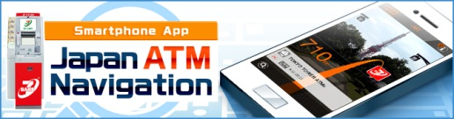
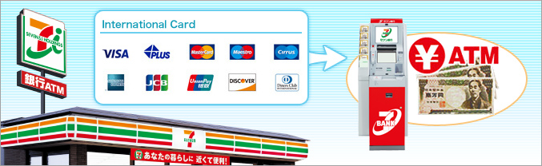
Foreign ATM cards also only work at select ATMs across the country. They are always accepted at Japanese Post Bank and Seven Bank ATMs. Japanese Post Bank ATMs are found in every post office. Even if the post office is closed you still can access the ATMs on weekends and holidays. Hours vary by location. Seven Bank ATMs are located in every 7-11 Convenience Store, including the one in front of Sonoda Women’s University. Service hours are almost 24hours except for a small period of time around midnight that varies by card. Neither of these ATMs have a fee, however your local bank or credit card might charge you a fee per usage. Please check with your bank or credit card issuing company for more information. Sometimes both Japanese Post Bank and Seven Bank ATMs can also be found in large train stations, department stores and shopping malls. Seven Bank also has a smartphone app for free listing all of their locations. See the following link: http://www.sevenbank.co.jp/english/personal/atm/app/

Operating Instructions for Seven Bank ATMs
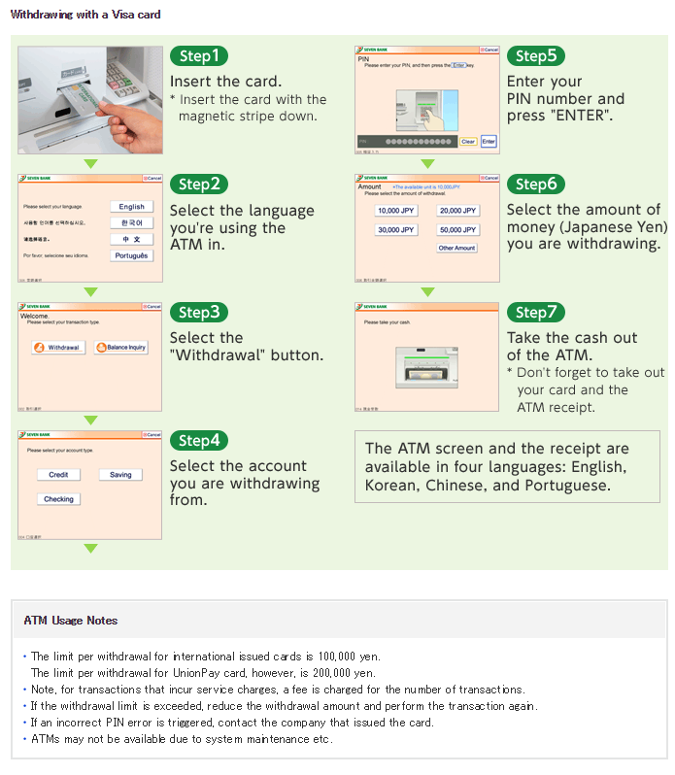(screen capture from Seven Bank homepage)

International ATM Map
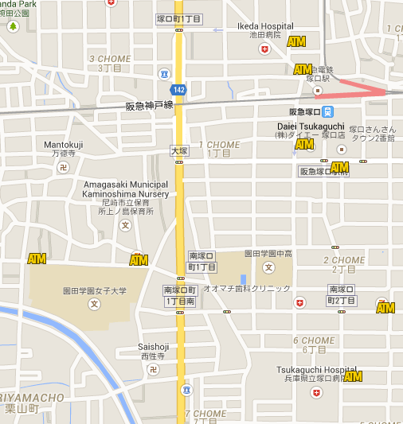

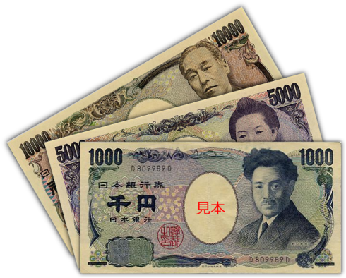
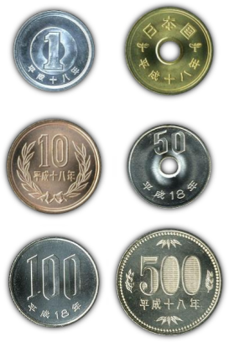
Japanese Currency
Bills for 1000, 5000 and 10,000 yen are in wide circulation. You might come across a 2,000 yen bill but they are quite rare. Most vending machines only take 1,000 yen bills. Coins come in 1, 5, 10, 50, 100 and 500 yen. Vending machines do not take 1 and 5 yen coins.

Manners
Japan’s sometimes confusing manners are an obstacle course for anyone who has decided to travel here. Thankfully, for short or long term exchange students, most Japanese people are very forgiving. No one expects tourist and exchange students to understand and follow all of the manners, but there are a few major ones that everyone should follow to make their stay a pleasant one.
- Shoes: Shoes should be taken off when entering a home, some hotels and in other facilities. The entrance will almost always have a small step up indicating the point where outdoor shoes must be removed. In most schools, from kindergarten to high school, indoor shoes must be worn. Guests will be provided with slippers in this case. Inside houses a small step up also means that slippers should be taken off. Only socks or bear feet are permitted on traditional tatami floors.
- Clothing: Japanese clothing is actually quite modest and conservative in many ways despite the short skirts favored by some young women. Low cut dresses and tops in particular might attract unwanted attention in both work and casual situations. Socks and tights with holes in the feet are also considered rude. All exchange students should bring some something more formal but still comfortable to wear for the presentation and closing ceremony.
- Cell Phones: Talking on your cellphone on the train or in public is considered quite rude. If you must take a call on a train it is best to make it short and talk quietly. In a crowded public space people typically walk to an empty corner to take their call. Also, on trains cellphones should be set to their silent or vibrate only mode. This is typically called “manner mode” on Japanese phones.
- Public Consumption of Food: Eating while walking is uncommon in Japan. On the commuter train eating anything more than a small candy or gum is discouraged. However, on longer routes or the shinkansen, people are encouraged to eat a meal on the train.
- In a group: Japan is a busy place with many busy people. In a group if you stop please try to congregate in a place that does not inhibit movement around you.
- Meals: Wait for everyone to get their meals before you begin eating, especially at restaurants and with drinks. Chopsticks should not be pointed at people or stabbed into food. In particular never stab your chopsticks into rice and leave them there.
- Greetings: The simple good morning and greetings like that is very important in Japanese culture. Even if you do not speak any Japanese try your best to greet people cheerfully and with a slight bow.
- Host family considerations: In a host family situation it is important to try your best to see everything from the host’s view. Japanese people, in general, dislike direct confrontations and will most likely never mention any thing you do which was taken as rude. This makes it very difficult to mediate sometimes. Do your best to ask permission and look at what the other family members are doing to see what is and what is not acceptable in your host family. Also, it is very important to bring a gift for the host family.

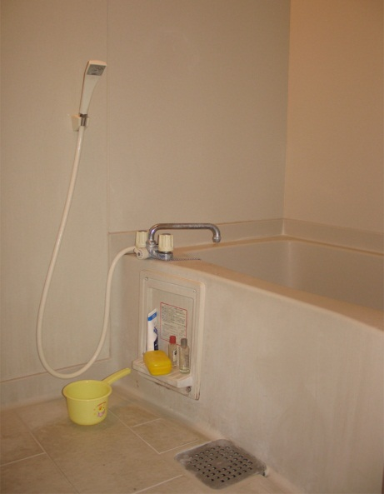
Bathing
Bathing in Japan is an important part of the culture here. Baths are poured once and shared among the family members. Traditionally the father gets to use the water first, but in reality the order of who uses the baths is up to each family. The bath is for soaking and relaxing only. Washing of with soap and shampoo is done in the shower before entering the bath. Towels should not be put into the bathwater and do your best to dry yourself before leaving the as to not track water out of the bath.

Public Baths
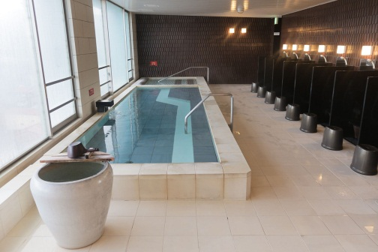
Public baths and hot springs (sento 銭湯and onsen 温泉) have extra manners to be aware of. These are typically found on posters written in multiple languages. If you are in a host family they will likely take you to a hot spring of some type during your stay. These are gender separated, but you will be required to be nude to enter the baths. For many visitors to Japan this is a highlight of their trip, but it is also a source of nervousness. As this is a common thing in Japanese society, group nudity is not a big issue and is definitely not a sexualized or body shaming experience. It is very much an everyday thing for most people and guests should try to think of it like that. Public bathing is part of the bonding rituals that help create the peaceful society that Japan is famous for. Besides all of that, it is the most relaxing thing you can imagine. The typical Japanese bath is 41ºc so do be careful about overexposure. Depending on the type of bath you might need to bring your own soap and shampoo. It is common to bring a change of clothes, a big towel for afterwards, a small towel for use in the bathing area, toothpaste and a toothbrush plus any other toiletries that you need. It is polite for women who are menstruating to refrain from entering the baths either at home (using the shower is fine) or in a hot spring. Lastly, other than typical sento people with tattoos are not allowed. Please make sure to tell your host family and the SWUIEC if you have a tattoo so we can plan accordingly.
Image: Wikipedia user sanmai
Image: Wikipedia user MC MasterChef
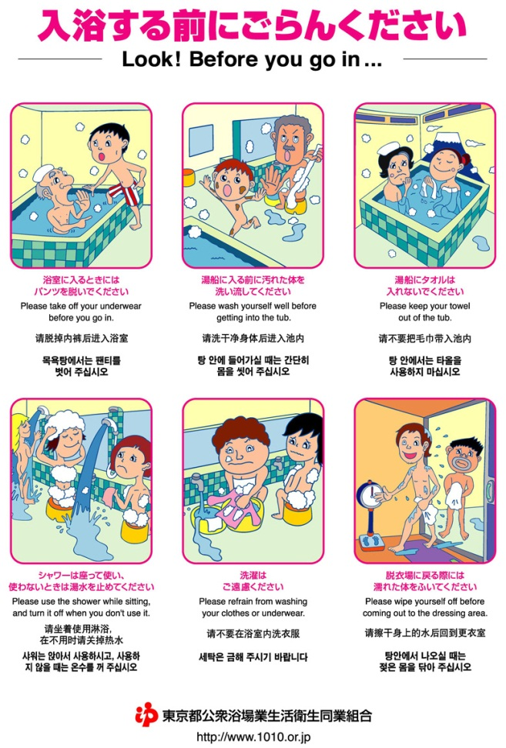
Image: Sento Manners Poster, Tokyo Public Bathhouse Association

Toilets
Sadly you will not find the magical high tech toilets in at Sonoda Gakuen, but you will run into them in hotel rooms, host families, and stores. In houses and places where you have taken your shoes off when you enter there will be special slippers for use in the toilets. Make sure not to wear them out of the toilet room. Do not worry if you do so, everyone will get a big laugh about it. Printed on the flushing handle or remote control on more expensive models is a 大 for big and a 小 for small. Many toilets have a water spigot at the top for washing your hands with the water that is filling the tank. Sometimes there is soap but it is not customary to always use soap after using the toilet. Most public toilets do not have hand towels including those at Sonoda Gakuen so most people carry a small pocket towel with them at all times. Some, mostly older train station, restrooms do not have toilet paper. Make sure to check in the stall if you need any. Tissues will almost always be for sale in a machine near the entrance for \50.

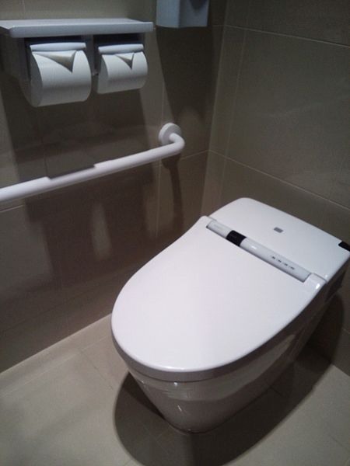
Western Style (sitting) 洋式
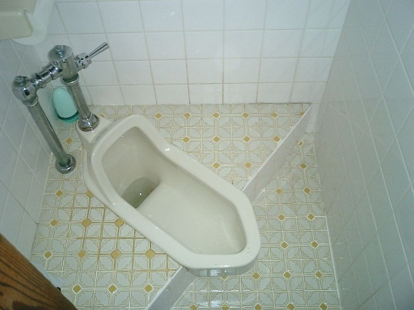
Western style toilets are the same back home but many also have a heated seat and automated bidet called a washlet. There should be icons for the rear, women’s, and stop buttons. Besides that there are settings for the strength of the water, the heat of the water and the heat of the seat. The most expensive models also have massage and air dry features.

Japanese Style (squatting) 和式
Japanese style toilets are still common in older buildings and there is a good chance that you will encounter one during your stay. You use them by squatting forward facing the tank with the door behind you.
Image: Wikipedia user Poco a poco
Image: Wikipedia
user 浪速丹治

Websites for Manners
*General Etiquette*
These are very, very basic tips: https://www.japan-guide.com/e/e622.html

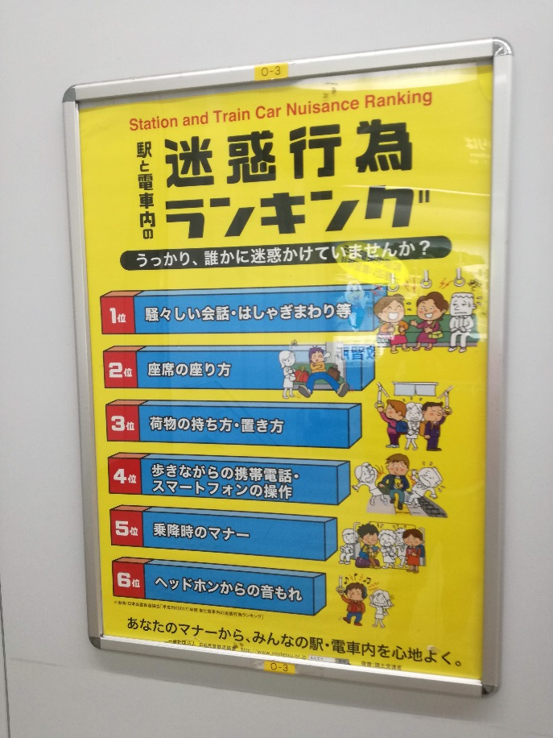
This one is a good place to start: https://www.gooverseas.com/blog/tips-for-living-with-a-japanese-host-family

This one is a bit more in-depth and funny. Tofugu is a good reference for all things Japan: https://www.tofugu.com/japan/japanese-etiquette/

*Public baths / Hot Springs
(From David’s Website)*

General info: http://www.iloveyu.jp/basicguide/

Manners & Risks: http://www.iloveyu.jp/manners-risks

The Japanese Language
Japanese is ranked as one of the most difficult languages to master, but thankfully the pronunciation and grammar is relativity easy. Basically the language works in a subject – object – verb order however the subject is often dropped. Singular and plural nouns are also not differentiated. There are levels of politeness that change depending on the status of the person. There is a common form of Tokyo Japanese that is promoted by the government, however regional dialects are powerful. At and around Sonoda you will hear a combination of common Japanese and Kansai dialect. While both Kansai and common Japanese is easily understandable some dialects like those in Iwate Prefecture or Kagoshima Prefecture are unintelligible even to native speakers.

Written Japanese
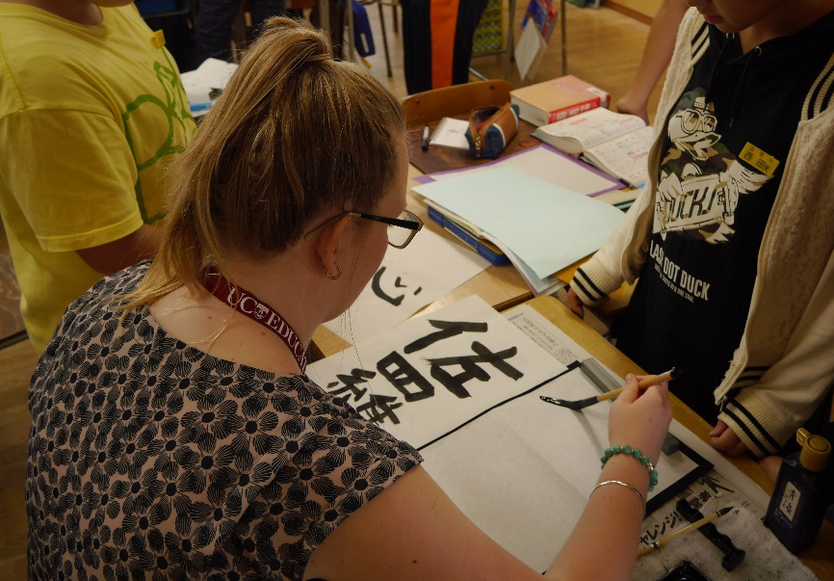
Japanese is written in 4 scripts, 3 of which are used in conjunction with each other. Chinese characters are called Kanji (漢字) most of these are similar their Chinese counterparts but some have been developed in Japan. Each Kanji has multiple ways it could be vocalized. The first script children used is Hiragana (ひらがな) this is used in place of Kanji or in conjunction with Kanji. Each character represents a vowel + a consonant, or a vowel + 2 consonants. Next is Katakana (カタカナ) which works the same way as Hiragana, but is used for foreign words or sounds like “oomph” or “bark.” Both Hiragana and Katakana have been used for native Japanese words that do not have a Kanji counterpart such as particles. Lastly Japanese also use Romanji (ローマ字) which is the transliteration of Japanese into Latin (AKA Roman) script. This is used mostly for the benefit of non-Japanese speakers and Japanese language learners. There are various methods of Romanji so sometimes “ち” can be Romanized as “chi” and “ti.” The former is more prevalent. Chinese written language came to Japan sometime around 2,500 years ago along with Buddhism via the Korean peninsula. Kanji was adapted to fit the Japanese language however imperfectly. Initially Katakana was developed to be used at pronunciation guides and with official documents while hiragana was later developed for casual writing.
Image: An exchange student trying Japanese calligraphy
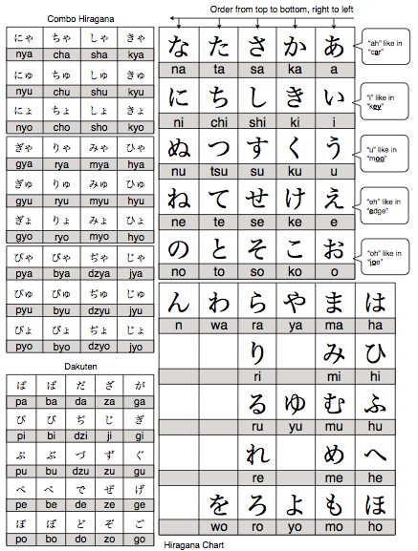
Image: Hiragana Chart from Tofugu.com
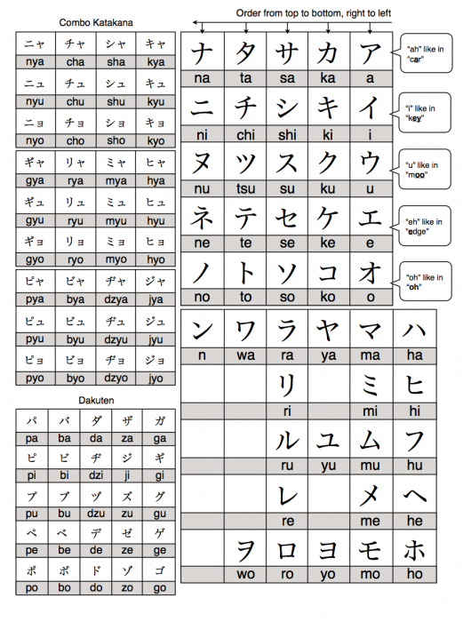
Image: Katakana Chart from Tofugu.com

Greetings & Daily Words
good morning | Ohaiyo Gosaimazu | おはようございます
good afternoon | konnichiwa | こんにちは
good evening/night | konbanwa | こんばんは
Hello (on a phone) | moshi-moshi | もしもし
excuse me | sumimasen | すみません
sorry (casual) | gomen | ごめん
sorry (polite) | gomennasai | ごめんなさい
“let’s eat” prior to eating | itadakimasu | いただきます
“we ate” after eating | gochisosama | ごちそうさま
yes / no | hai / iie | はい／いいえ

Important Kanji
days of the week |  |  | tea | 茶 | cha
Sunday | 日曜日 | nichiyobi | water | 水 | mizu
Monday | 月曜日 | getsuyobi | coffee | コーヒ | kohi
Tuesday | 火曜日 | kayobi | alcohol | 酒 | sake
Thursday | 水曜日 | suiyobi | milk | 牛乳 | gyunyu
Friday | 木曜日 | mokuyobi | sugar | 砂糖 | sato
Saturday | 土曜日 | doyobi | shellfish | 貝 | kai
numbers |  |  | others
1 | 一 | ichi | woman | 女 | onna
2 | 二 | ni | man | 男 | otoko
3 | 三 | san | entrance | 入口 | iriguchi
4 | 四 | shi | exit | 出口 | deguchi
5 | 五 | go | small | 小 | sho
6 | 六 | roku | middle | 中 | chu
7 | 七 | nana/shichi | large | 大 | dai
8 | 八 | hachi | year | 年 | nen
9 | 九 | kyu | month | 月 | getsu
10 | 十 | jyu | day | 日 | niche
20 | 二十 | nijyu | hour | 時 | ji
100 | 百 | hyaku | minute | 分 | pun/fun
200 | 二百 | nihyaku | city | 市 | shi
1,000 | 千 | sen | sky | 空 | sora
2,000 | 二千 | nisen | river | 川 | kawa
10,000 | 万 | man | mountain | 山 | yama
20,000 | 二万 | niman | train | 電車 | densha
food |  |  | car | 車 | kuruma
chicken | 鶏肉 | toriniku | station | 駅 | eki
beef | 牛肉 | gyuniku | left | 左 | hidari
pork | 豚肉 | butaniku | right | 右 | migi
fish | 魚肉 | gyoniku | book | 本 | hon
meat | 肉 | niku | desk | 机 | tsukue
rice | 米・ごはん | kome/gohan | chalkboard | 黒板 | kokuban
bread | パン | pan | chair | 椅子 | isu

Japanese Titles
Japanese never address each other using their first names in formal situations. First names and nicknames can be used in casual, familiar, or group situations. There are a great number of titles and most of these are only used for last names but some can be added to first names.
さん | san | general use polite form
様 | sama | more elevated polite form
先生 | sensei | teacher / doctor
教授 | kyojyu | professor
ちゃん | chan | used for younger girls in a casual manner with the first name
君 | kun | used for younger boys in a casual manner with the first name

Extra School words
principal | 校長先生 | koucho sensei
vice principal | 教頭先生 | kyoto sensei
Japanese | 国語 | kokugo (lit. country language)
English | 英語 | eigo
math | 数学 | sugaku
science | 理科 | rikai
PE | 体育 | taiiku
social studies | 社会 | shakai
calligraphy | 書道 | shodo
art | 美術 | bijyutsu
school lunch | 給食 | kyushoku
student | 学生・生徒 | gakusei / seito
preschool (day care) | 保育園 | hoikuen
kindergarten | 幼稚園 | yochien
elementary school | 小学校 | shogakko
junior high school | 中学校 | chugakko
high school | 高校 | koko
2 year college | 短大 | tandai
4 year college/university | 大学 | daigaku

Links from David
Here are some places and things I personally recommend for you enjoy or to make your time here more enjoyable.
1) Fukuchiyama Rail Line Hike:
http://sleepytako.blogspot.com/2012/08/abandoned-fukuchiyama-line.html
From my old, old blog. The course is now open to the public.
2) Kono-san Hike:
https://www.yamakei-online.com/cl_record/detail.php?id=42201
https://www.yamareco.com/modules/yamareco/detail-1159571.html
An easy hike with a great view, large rocks, waterfalls and more
http://www.pref.osaka.lg.jp/midori/midori/g07-ikoikomapuriba.html
いこいこまっぷ (hiking map by Osaka prefecture with a lot of good routes)
3) Hiking in the mountains above Kobe (Mt Rokko)
http://www.yamareco.com/modules/yamainfo/bookinfo.php?bid=52
Great map for exploring the Rokko Mountains
https://www.yamareco.com/modules/yamareco/detail-1263714.html
Easier hike using a bus to get most of the way up then down to Arima Onsen
4) Tanisenotsuribashi (longest pedestrian suspension bridge in Japan):
https://www.visitnara.jp/venues/A00541/
One way to get there
https://www.narakotsu.co.jp/language/kr/local/totsukawa.html
5) Kansai Railway Network Map (ask for it at information counters across Kansai):
http://www.hanshin.co.jp/global/en/images/map/rosenmap.pdf
6) 青春１８きっぷ Seishun18Kippu:
https://www.japan-guide.com/e/e2362.html
7) Saikoku 33 Pilgrimage 西国３３:
http://www.taleofgenji.org/saigoku_pilgrimage.html
8) Apps & Websites (Apple App Store links, I use the Android versions)
(ア) 乗り換え案内：
https://itunes.apple.com/jp/app/%E4%B9%97%E6%8F%9B%E6%A1%88%E5%86%85/id299490481?mt=8
(イ) 駅.Locky
https://itunes.apple.com/jp/app/%E9%A7%85-locky-%E3%82%AB%E3%82%A6%E3%83%B3%E3%83%88%E3%83%80%E3%82%A6%E3%83%B3%E5%9E%8B%E6%99%82%E5%88%BB%E8%A1%A8/id335126084?mt=8
(ウ) Rail Map
https://itunes.apple.com/jp/app/rail-map/id1077627714?l=en&mt=8
(エ) Rakuten Travel (Hotel Booking)
https://travel.rakuten.co.jp/
(オ) じゃらん (Hotel Booking)
https://www.jalan.net/
(カ) Bosai.net
http://bosai.net/
(キ) Weathernews
https://itunes.apple.com/jp/app/%E5%A4%A9%E6%B0%97%E4%BA%88%E5%A0%B1%E3%82%A6%E3%82%A7%E3%82%B6%E3%83%BC%E3%83%8B%E3%83%A5%E3%83%BC%E3%82%B9%E3%82%BF%E3%83%83%E3%83%81/id302955766?l=en&mt=8
(ク) NHK World:
https://www3.nhk.or.jp/nhkworld/en/app/
(ケ) NHK News & Bosai:
https://www3.nhk.or.jp/news/news_bousai_app/index.html
(コ) Rikaikun
https://chrome.google.com/webstore/detail/rikaikun/jipdnfibhldikgcjhfnomkfpcebammhp?hl=en
(サ) WWWJDIC
http://nihongo.monash.edu/cgi-bin/wwwjdic?1C
(シ) アルク
https://www.alc.co.jp/
(ス) Kanji Search Site
https://kanji.sljfaq.org/mr.html
(セ) Rikai
http://www.rikai.com/perl/Home.pl
(ソ) 7-11 ATM Search (best ATMs for international cards)
https://www.sevenbank.co.jp/english/personal/atm/app/

Google Map
A Google Map with places mentioned in this Guidebook and more is available online for viewing at:
https://goo.gl/MOECJw

Holes in socks are considered rude especially as you will be taking your shoes off to enter many places.
Sizes over 27cm can be difficult to find so bringing shoes is recommended if you have larger feet.
Bathing suits can be found, but they are expensive and larger sizes are rare.
This does not be extremely fancy or a full suit.
It is good to have a range from casual jeans to “business formal” pants or skirts.
Often Japanese restrooms have paper towels to dry your hands with.
Western style deodorant is difficult to near impossible to find in Japan.
Gift giving is an important part of Japanese culture. Bring one special gift for your homestay if applicable and also bring smaller gifts to pass out to people you befriend during your stay. Locally made products, candies, and easily transportable foods are recommended. Tourist souvenirs are also fine. Meat products like beef jerky will confiscated by Japanese customs if found.
It is required that you leave your suitcase at the hotel or university during the weekend homestays.
Mansion is a loan word from English meaning large apartment building.
Shinkansen (新幹線) is the common name for “bullet train” which is not used in vernacular speech in Japan.

